Given an m x n binary matrix filled with 0's and 1's, *find the largest square containing only* 1's *and return its area*.

**Example 1:**

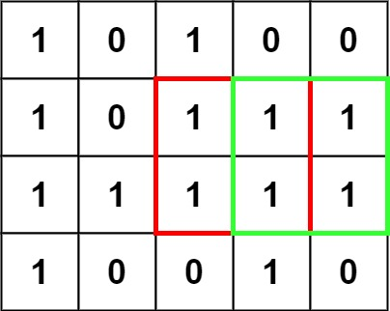

Input: matrix = [["1","0","1","0","0"],["1","0","1","1","1"],["1","1","1","1","1"],["1","0","0","1","0"]]  
Output: 4

**Example 2:**

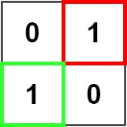

Input: matrix = [["0","1"],["1","0"]]  
Output: 1

**Example 3:**

Input: matrix = [["0"]]  
Output: 0

**Constraints:**

* m == matrix.length
* n == matrix[i].length
* 1 <= m, n <= 300
* matrix[i][j] is '0' or '1'.